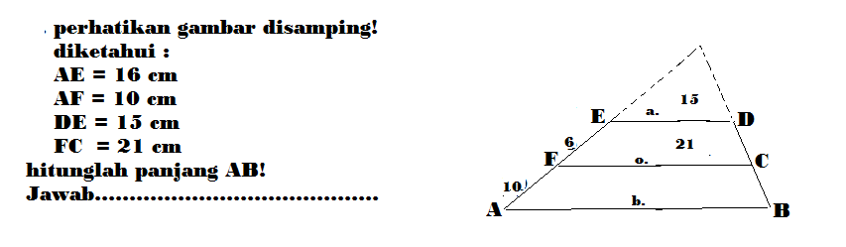

EO = ED
EO+EF = FC

EO = 15
EO + 6 = 21

EO(21) = 15(EO+6)
21EO = 15EO + 90

21EO – 15EO = 90
6EO = 90
EO =15

FO = 6 + 15 = 21

Skrg, bru bisa cari AB

FO = FC
FO+AF = AB

21 = 21
21 +10 = AB

21(AB) = 21(21+10)

21AB = 441 + 210

21AB = 651
AB = 651/21
AB= 31

